Semester | T.E. Semester V - Computer Engineering
Subject | IMR
Subject In-charge | Prof. Aniket Kundu

Student Name | Mrudula Kishor Sakpal
Roll Number | 24102A0073
Grade and Subject Teacher’s Signature

Prev Image | 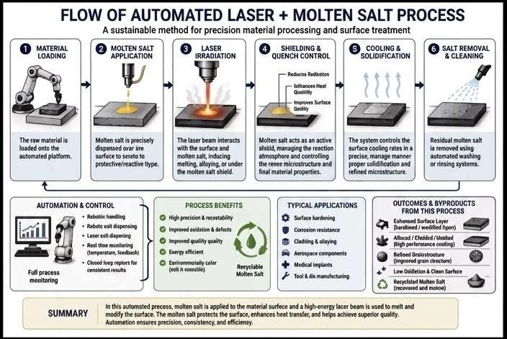
New Image | 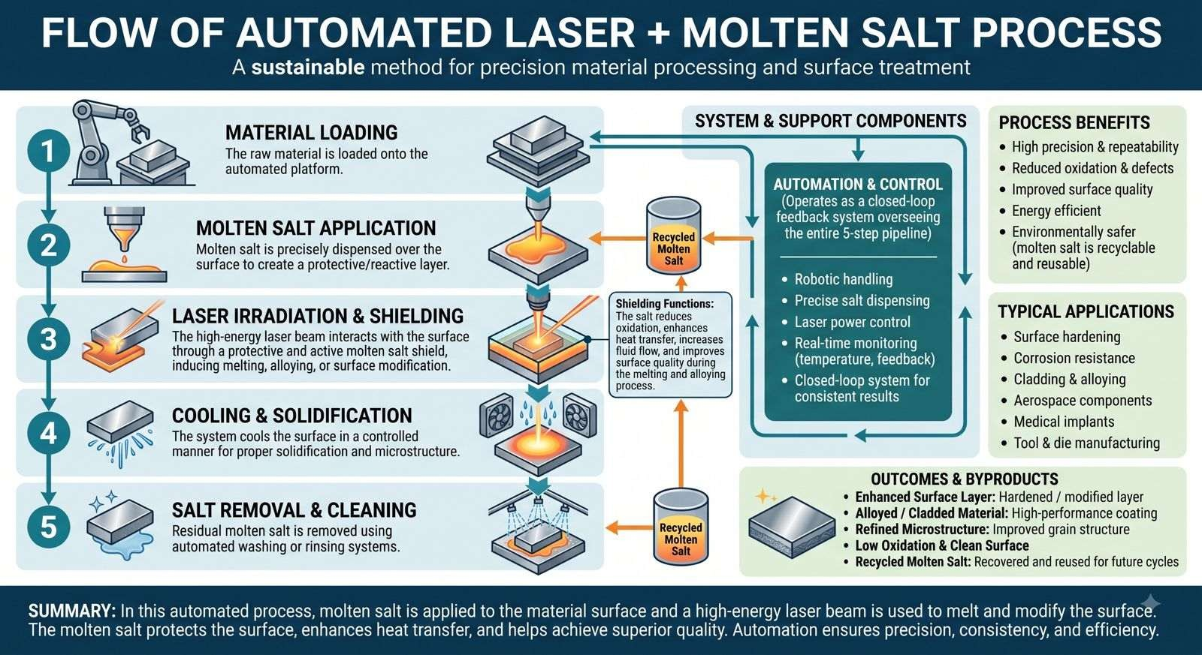

Changes Made | - Structural Flow (5 Steps vs. 6 Steps)  - New Image: Consolidates the process into 5 steps. Step 3 is "LASER IRRADIATION & SHIELDING," combining the laser action and the shielding function into a single phase with a detailed explanatory callout.  - Old Image: Divides the process into 6 steps. Step 3 is strictly "LASER IRRADIATION," and Step 4 is a separate "SHIELDING & QUENCH CONTROL" step.  - Text Quality and Spelling (Clean Text vs. AI Artifacts)  The most significant difference is the correction of numerous spelling errors, typos, and AI-generated "gibberish" text present in the old image.  Step Descriptions:  - Old: Contains mangled text like "dispensed ovar are surface to seseto to protective/reactive tlype" (Step 2) and "managing the reaction atmosphere and controlling the renee microstructure" (Step 4).  - New: Uses clear, grammatically correct English (e.g., "dispensed over the surface to create a protective/reactive layer").  Automation & Control:  - Old: Features misspelled bullets like "Rebotie handliog," "Laser eolt diapening," and "Cloced foep reptors." It also uses a brief subtitle "Full process monitoring."  - New: Corrects all bullets to standard English (e.g., "Robotic handling," "Laser power control") and includes a clearer descriptive subtitle: "(Operates as a closed-loop feedback system overseeing the entire 5-step pipeline)."  Process Benefits:  - Old: Lists misspelled benefits like "receetability," "osidation," "Enrirommoialy cofer (eolt is rooesble)," and repeats "Improved quality quality."  - New: Corrects these to "High precision & repeatability," "Reduced oxidation & defects," "Improved surface quality," and "Environmentally safer (molten salt is recyclable and reusable)."  Typical Applications:  - Old: Contains typos like "kardening," "oliaying," and "Teol & dis manufacturing."  - New: Corrected to "Surface hardening," "Cladding & alloying," and "Tool & die manufacturing."  Outcomes & Byproducts:  - Old: The title is "OUTCOMES & BYPRODUCTS FROM THIS PROCESS". The descriptions contain heavy artifacts like "Euhensed Surface Layer (barobined / wedified figon)" and "Recyclsted Malten Salt (recevored and motoe)."

- New: The title is simply "OUTCOMES & BYPRODUCTS". The text is fully corrected, offering clear definitions like "Enhanced Surface Layer: Hardened / modified layer" and "Recycled Molten Salt: Recovered and reused for future cycles."

Summary:
- Old: Contains minor typos ("automsted precess", "surfeca", "lacer", "heet", "Automotion", "efficienay").

- New: All typos in the summary block are fixed.

